Multiple-choice section

Question 1 [5.1]

Lilly has x bags of lollies, with p lollies in each bag. She gives q lollies to her friends.

The total number of lollies that Lilly has left can be written using algebra as:

A x + p – q B x + p + q C px – q D 

Question 2 [5.1]

A glass contains x mL of juice. I pour in another 30 mL then drink  of the juice in the glass. The amount of juice (in mL) now left in the glass can be written as:

A  B C x + 20 D x + 10

Question 3 [5.2]

Which of the following expressions has a constant term of 7?

A 7p + 2 B 7p2 C 3p – 7q D 

Question 4 [5.1]

How can the following statement be written using algebra?

‘Choose a number, multiply it by six, then subtract your answer from the square of the original number.’

A  B C 6() D 6()

Question 5 [5.6]

A like term for 2xyz is:

A –3yzx B 8xy C 2xy D 2yz

Question 6 [5.6]

Which of the following is obtained when 3p + 5q – 4p – 4q is simplified?

A p – q B p + q C -p – q D q – p

Question 7 [5.3]

Choose the correct algebraic rule for the following:

‘y is equal to the product of x and a number three less than x.’

A y = x + (x – 3) B y = x(3 – x) C y = D y = x(x – 3)

Question 8 [5.4]

Using the rule q =, where p = 8, q is equal to:

A 22 B 1 C 18 D 2

Question 9 [5.4]

A rule is given as P =. Which of the following statements is not true?

A Where n = 4, P = 7. B Where n = 10, P = 1.

C Where n = 8, P = 3. D Where n = 2, P = 17.

Question 10 [5.7]

A point is four units left and three units down from the point (3, 1). Which quadrant is the point in?

A 1 B 2 C 3 D 4

Question 11 [5.7]

Which of the following coordinate pairs lies furthest up the Cartesian plane?

A (6, 2) B (3, 6) C (0, 3) D (4, 5)

Question 12 [5.4]

Considering the table below, what is the rule for x and y?

|  |  |  |  |  |
| --- | --- | --- | --- | --- |
| x | 10 | 20 | 8 | 30 |
| y | 21 | 41 | 17 | 61 |

A y = 1 + 2x B x = 2y – 1 C x + y = 31 D y = 3(x – 3)

Multiple-choice total marks: ____ / 12

Short answer section

Question 13 4 marks [5.3, 5.7]

Use words from the list below to complete the following sentences.

coefficient linear graph x-axis relationship flowchart table of values quadrant

(a) A ____________________ is a step-by-step instruction for performing a set task.

(b) A _______________________ means that variables are connected in some way so that changing the value of one affects the value of the other.

(c) The point (-2, 0) lies on the ______________________________.

(d) The point (-1, -2) is in the third ________________________ of the Cartesian plane.

Question 14 2 marks [5.6]

Define ‘non-like terms’. Give two different examples of non-like terms.

Question 15 2 marks [5.1]

Write the following in simplest form using algebra.

(a) ‘a is multiplied by itself, b is multiplied by itself, then the two results are added together’.

(b)‘The square root of x is halved and then has 3 added to it’.

Question 16 4 marks [5.1]

Charlie has x T-shirts. Steve has five fewer T-shirts than Charlie. Sam has two more T-shirts than Steve.

Use algebra to write:

(a) The number of T-shirts that Steve has.

(b) The number of T-shirts that Sam has.

(c) The number of T-shirts that the three of them have altogether. (Simplify your answer.)

Question 17 4 marks [5.1]

At our home there are p cars, q bicycles, r tricycles and s unicycles. (Note: Tricycles have 3 wheels, unicycles have 1 wheel.)

(a) Write an expression for the total number of wheels.

(b) If there are six unicycles and one tricycle and 27 wheels altogether, find a possible set of values for p (cars) and q (bicycles).

Question 18 4 marks [5.2]

An adult ticket to the zoo costs $m and a child’s ticket to the zoo costs $n.

(a) Define the variables m and n.

(b) Seven children can enter the zoo for the same price as four adults. Write an equation for this situation.

(c) Write an expression for 14 child’s tickets in terms of m.

Question 19 4 marks [5.2]

A storage container of mass 140 kg contains 40 boxes. The total mass of the container and its contents is 1140 kg.

(a) If the variable is defined as the mass of one box, choose a pronumeral to represent the variable.

(b) Write an equation to represent the total mass of the container.

(c) Using the above equation, find the mass of one box.

Question 20 2 marks [5.3]

Beth and Daniel went to the Easter Show. Beth spent $25 more than half of the amount that Daniel spent. One variable represents the amount of Beth’s spending and another variable represents the amount of Daniel’s spending. Using two pronumerals to represent these variables, write an equation to represent the amount that Beth spent.

Question 21 4 marks [5.3]

‘To find y, multiply x by itself then double your answer’.

(a) Draw a flowchart for this rule.

(b) Write the rule using algebra.

(c) Copy and complete the following table of values for the rule.

|  |  |  |  |  |
| --- | --- | --- | --- | --- |
| x | 3 | 4 | 5 | 10 |
| y |  |  |  |  |

Question 22 3 marks [5.3]

Write each of these rules in simplest form using algebra:

(a) Subtract 5 from 2x, then multiply the result by 3 to find y.

(b) To find y, multiply x by 4 then subtract your answer from 30.

(c) To find y, find the product x and 5, then halve it.

Question 23 2 marks [5.3]

Write an algebraic rule for the following flowchart.



Question 24 2 marks [5.3]

The following table of values has only the y-values filled in. Use the flowchart to complete the table.

|  |  |  |  |  |
| --- | --- | --- | --- | --- |
| x |  |  |  |  |
| y | 4 | 28 | 60 | 48 |

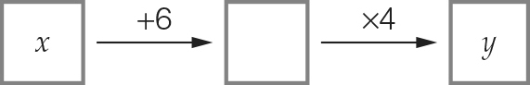

Question 25 5 marks [5.3]

Lou spent $65 on tools to make cards. In addition, each card she produced cost her $3.

(a) Using this information, fill in the table below.

|  |  |  |  |  |
| --- | --- | --- | --- | --- |
| Number of cards, n | 10 | 12 | 20 | 100 |
| Cost to produce the cards, C |  |  |  |  |

(b) Write a rule for the cost of producing the cards.

(c) What is the maximum number of cards Lou can make if the total cost C is to be kept under $1000?

Question 26 2 marks [5.4]

Answer true or false for each of the following.

(a) If you substitute a = 5 into b = , you get b = 6.

(b) If you substitute a = 5 into C = 2a + a2, you get C = 20.

Question 27 2 marks [5.4]

Use the rule to complete the table of values below.

n = 5(30 – 2m)

|  |  |  |  |  |
| --- | --- | --- | --- | --- |
| m | 5 | 10 | 12 | 14 |
| n |  |  |  |  |

Question 28 4 marks [5.4]

The distance d metres an object will fall in t seconds can be calculated using the formula d = 5t2.

(a) How long will it take an object to fall 245 metres?

(b) If an object has fallen for 9 seconds, how far has it fallen?

Question 29 6 marks [5.5]

Here is a matchstick pattern of shapes.

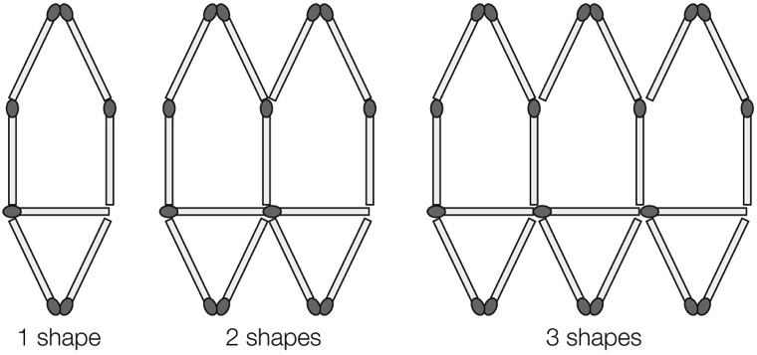

(a) Complete the table below.

|  |  |  |  |  |  |
| --- | --- | --- | --- | --- | --- |
| Number of shapes, S | 1 | 2 | 3 | 4 | 5 |
| Number of matches, M |  |  |  |  |  |

(b) Find the general rule that connects the number of matches to the number of shapes.

(c) Use your rule to find the number of matches required to build 30 shapes.

(d) How many shapes can you build with 200 matches?

Question 30 6 marks [5.6]

Simplify each expression where possible by collecting like terms.

(a) 23y – y + 5 (b) 10ab – 7ba – 3ba

(c) 2a2 + 5a2 – 4a2 (d) 2x – 5x + 4

(e) 2p + 9q – 3p – 10q (f) m + 10 + 2n + m – 6

Question 31 2 marks [5.6]

Nelson earns $y each month and spends $x of this amount each month. How many years will it take him to save 24y – 24x dollars?

Question 32 5 marks [5.7]

(a) Write the coordinates of each of the following points shown below.

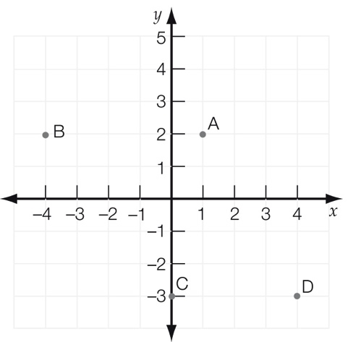

A __________ B ___________ C ____________ D ___________

(b) If you moved point D up 5 units and left 2 units what would its new coordinates be?

Question 33 8 marks [5.8]

(a) Plot the following points on the number plane and draw a straight line passing through all points.  
(-1, 1), (0, 3), (1, 5), (2, 7)

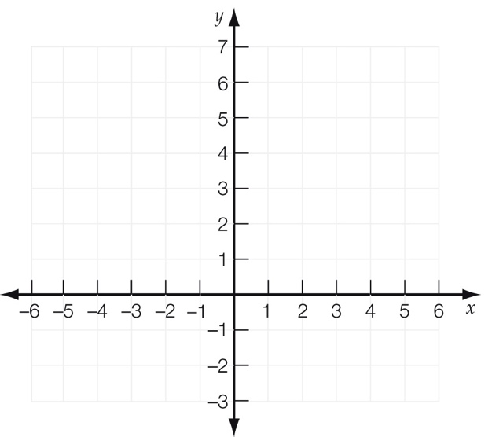

(b) Summarise the set of points in the table below.

|  |  |  |  |  |
| --- | --- | --- | --- | --- |
| x |  |  |  |  |
| y |  |  |  |  |

(c) Write a rule linking the x- and y-values.

(d) If (20, y) is on this line, find the value of y.

Question 34 3 marks [5.9]

A square pyramid (S) has five faces and five vertices (corners).

A rectangular prism (R) has six faces and eight vertices.

A triangular prism (T) has five faces and six vertices.

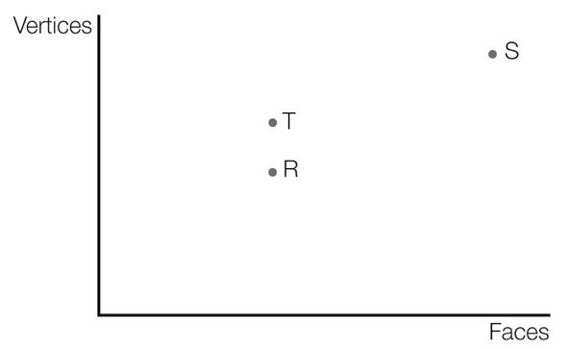

Write the positions of S, R, and T as coordinates.

S _____________ R _________________ T ________________

Question 35 5 marks [5.9]

Four nails are labelled A, B, C and D.

* Nails A and B are of equal length.
* Nails C and D are of equal width.

(a) Which of the graphs below best represents the situation?

Graph 1 Graph 2 Graph 3 Graph 4

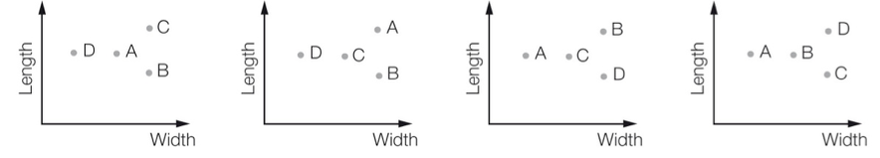

(b) Represent the same information on the point graph below.

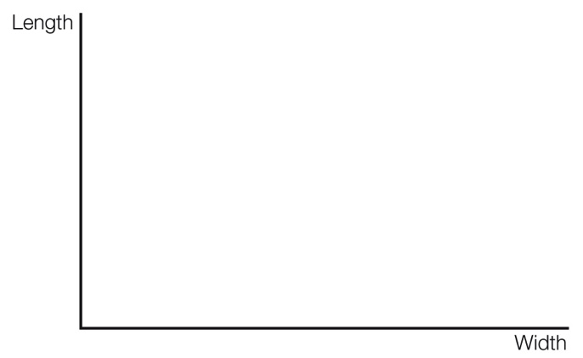

(c) Which nail is the largest in graph 1?

(d) Which nail is the smallest in graph 4?

Question 36 11 marks [5.9]

Justin travelled by train from his suburb to the city for a concert. On his way home, he stopped for a meal at a café, which was one train stop from the concert, before catching the express train home. This information is shown on the travel graph below.

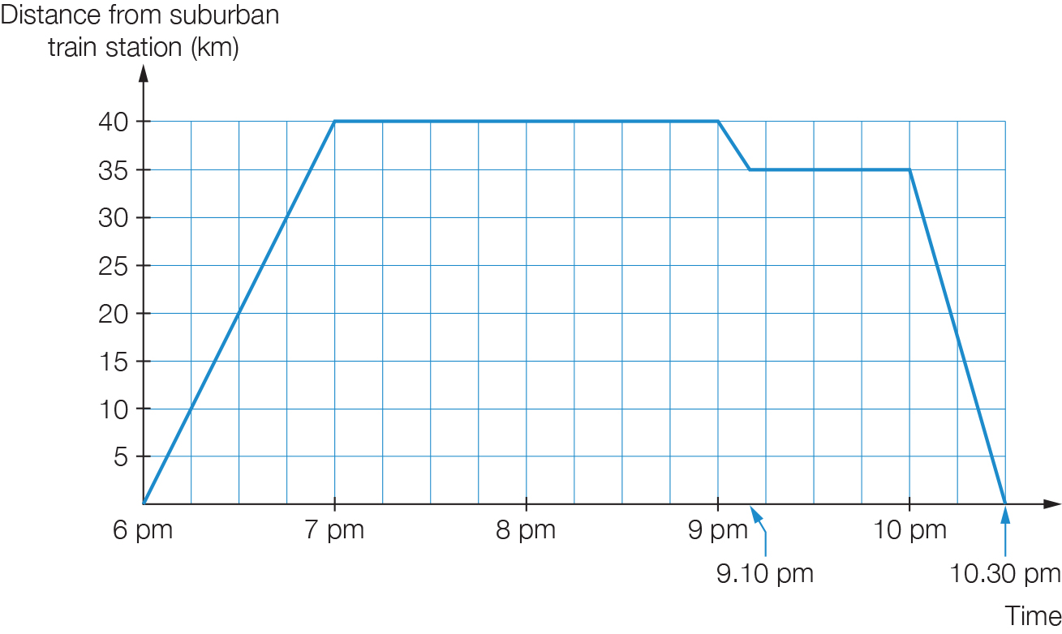

(a) What time did he leave home?

(b) How much time did the train ride to the concert take?

(c) How much time did the concert go for?

(d) How much time did Justing spend travelling on the train that day?

(e) What was the total distance travelled?

(f) At what speed (km/hr) was the express train travelling?

(g) If Justin had returned home at 10:20 pm instead of 10:30 pm, at what speed would the express train have been travelling?

Short answer total: _________ / 96

Extended answer section

Question 37 3 marks [5.2]

Bart bought notebooks, pencils and erasers for his siblings. The notebooks cost $4 each, the pencils cost $2 each and the erasers cost $3 each.

(a) Write an equation to represent the total cost.

(b) Altogether Bart spent $28 on the items. How many of each item could he have bought?

Question 38 7 marks [5.3]

Courtenay has saved some money in an account for a trip. She deposits an extra $500 into her account, then uses half of her total savings to pay the airfare. Then she spends $200 on travel insurance.

(a) Draw a flowchart to show the amount that Courtenay has spent altogether (y). Let x be the initial amount of Courtenay’s savings.

(b) Write an algebraic rule to describe the flowchart.

(c) Use the rule to find how much Courtenay spent if she started with $5000 in her account.

(d) How much does Courtenay have left in her account?

Question 39 6 marks [5.4]

Chris is building a timber deck. To complete the deck he needs to have 10 nails for every board as well as an extra 30 nails.

(a) Write a formula using algebra to represent the number of nails required. (Let b be the number of boards and n be the total number of nails.)

(b) Once the boards have been laid, Chris stains the deck. He knows that one can of stain covers  
70 boards. Write a formula using algebra to represent the number of cans required.  
(Let b be the number of boards and C be the number of cans.)

(c) Use the formulas you have written to find the number of nails and cans of stain that Chris will need for 140 boards.

(d) Chris builds another deck with the same requirements for nails and stain. If he uses exactly two cans of stain, how many nails does he need for the boards?

Question 40 5 marks [5.6]

I open a bank account. In the first week I deposit $x. Each week after that, I deposit $2 more than the previous week.

(a) Write an expression (in simplest form) for the amount of the fifth deposit.

(b) Write an expression to represent that total amount deposited in the first 5 weeks.

(c) What was the initial deposit if there is $80 in the account after 5 weeks?

Question 41 4 marks [5.8]

(a) Plot the points (2, 5) and (4, 9) on the Cartesian plane below.

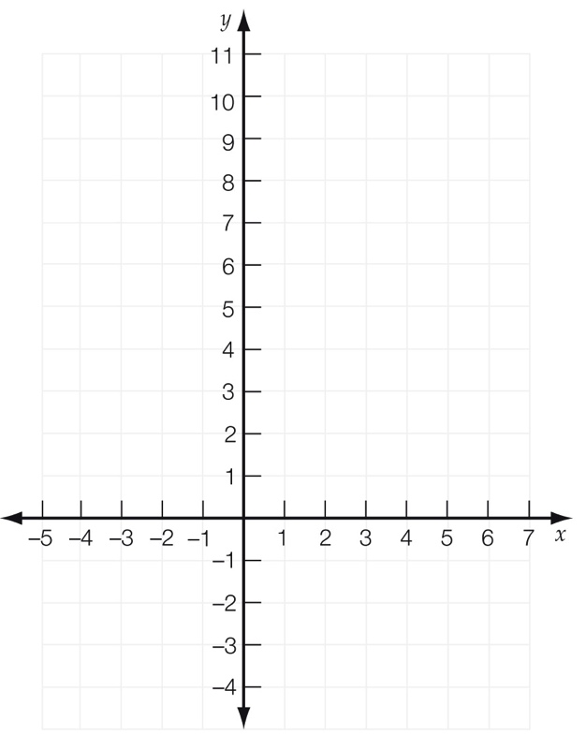

(b) Draw a straight line through these points.

(c) Draw a line parallel to this line that passes through the point (4, 1).

(d) Draw a horizontal line through the point (2, 5).  
State the x-value of the point where this horizontal line meets the line you drew in (c).

Extended answer total: _________ / 25

TOTAL test marks: _______ / 133